AI Assisted Coding - End Exam

2503A52L16 SUBSET:08
Q1: Design inverted index for search.
Task 1: Use AI to implement index builder
Prompt : Build a simple inverted index for product documents. Tokenize text and map each word to the document IDs.
Code / Logic (Short Version) :
docs = {
1: "Red cotton shirt for men",
2: "Blue denim jeans for women",
3: "Comfortable cotton jeans for kids"
}
index = {}
for d, text in docs.items():
for w in text.lower().split():
index.setdefault(w, []).append(d)
print(index)

output :
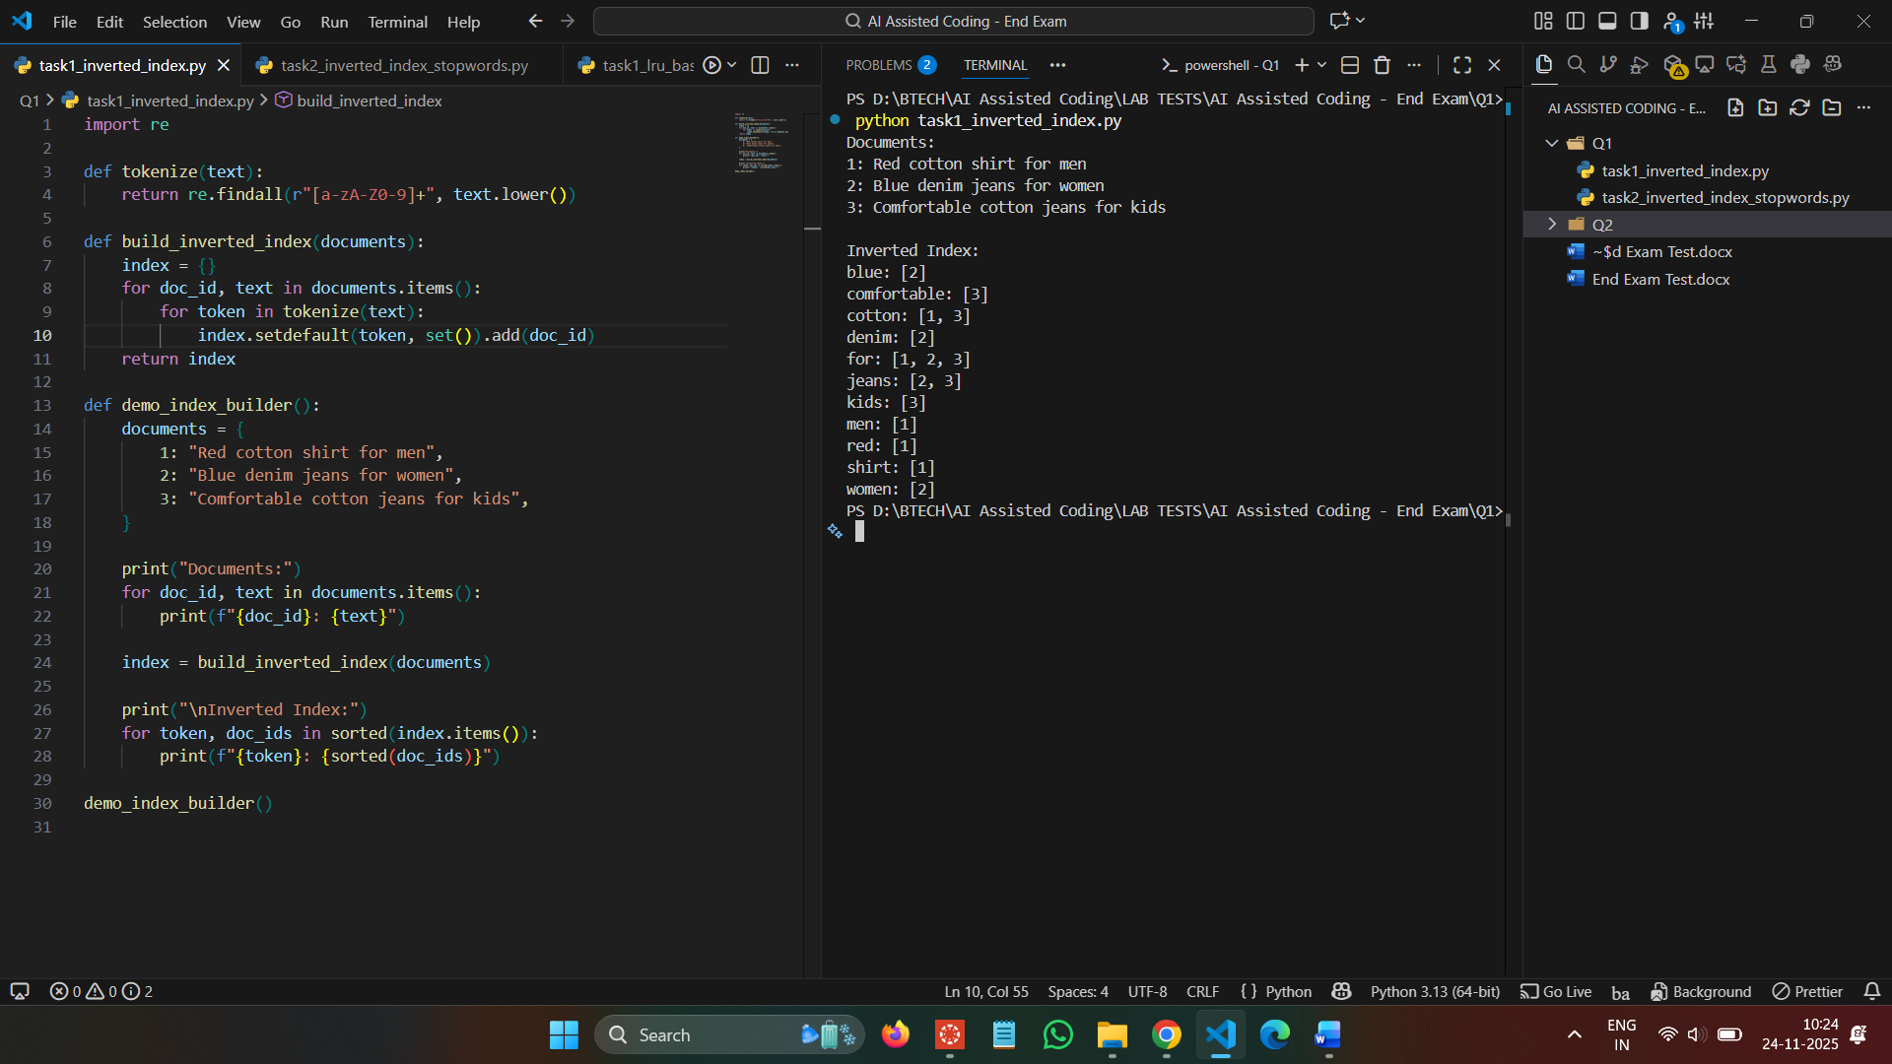
Task 2: Add support for tokenization and stopwords.
Prompt : Improve inverted index by removing stopwords and add a search function that returns documents containing all query words.
Code / Logic :
stop = {"for","the","a"}
docs = {
1:"red cotton shirt for men",
2:"blue denim jeans for women",
3:"cotton jeans kids"
}
index = {}
for d, t in docs.items():
for w in t.split():
if w not in stop:
index.setdefault(w, []).append(d)
def search(q):
words = q.split()
res = set(index.get(words[0], []))
for w in words[1:]:
res &= set(index.get(w, []))
return res
print(search("cotton jeans"))
Output :
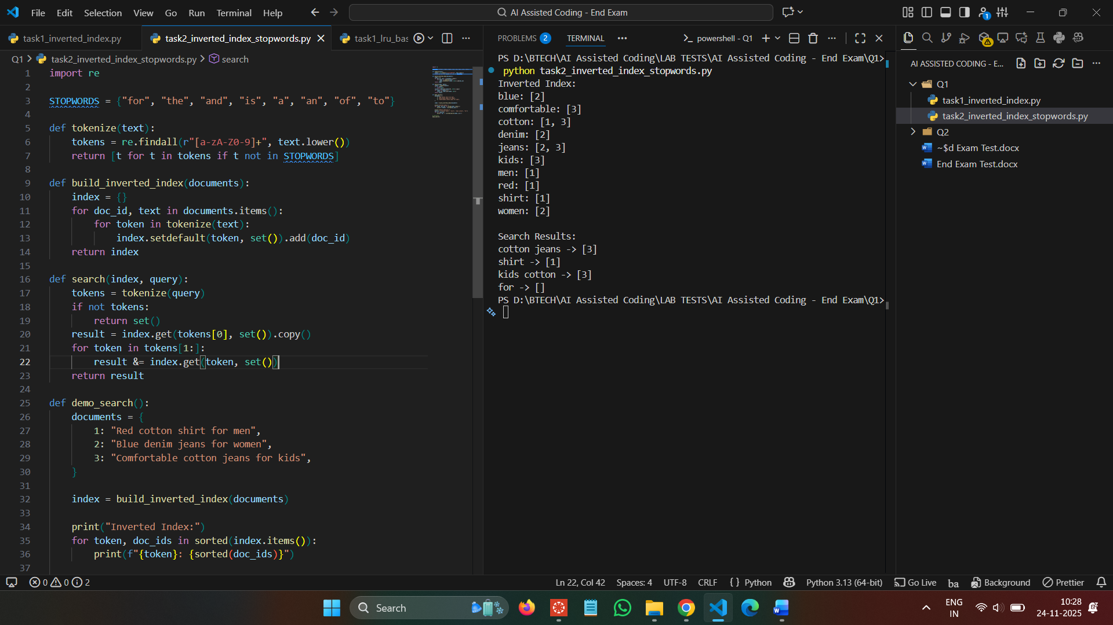
Observation :
Stopwords are removed from indexing to improve search accuracy.
The search function returns documents that contain all the words in the query.
Results are more meaningful because useless words like “for” are ignored.

Q2: Implement LRU cache for product pages.
Task 1: Use AI to scaffold LRU implementation
Prompt
Implement a basic LRU cache that evicts the least recently used item when full.
Code / Logic:
from collections import OrderedDict
class LRU:
def __init__(self,c): self.c=c; self.d=OrderedDict()
def get(self,k):
if k not in self.d: return None
self.d.move_to_end(k); return self.d[k]
def put(self,k,v):
if k in self.d: self.d.move_to_end(k)
self.d[k]=v
if len(self.d)>self.c: self.d.popitem(last=False)
cache = LRU(2)
cache.put("P1",1)
cache.put("P2",2)
cache.get("P1")
cache.put("P3",3)
print(cache.d)

Output :
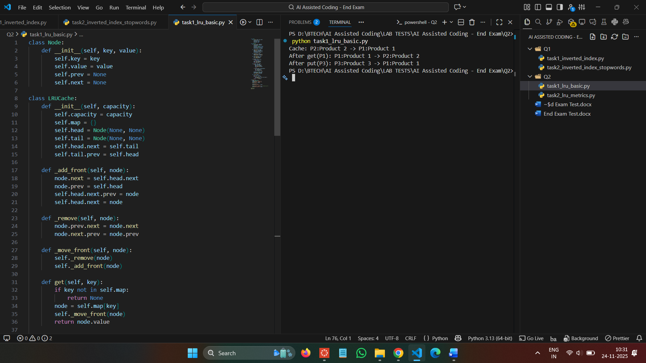
Task 2: Add metrics and eviction tests.
Prompt: Extend LRU cache to track hits, misses, and evictions and show final metrics.
Code / Logic :
from collections import OrderedDict
class LRU:
def __init__(self,c):
self.c=c; self.d=OrderedDict()
self.h=0; self.m=0; self.e=0
def get(self,k):
if k not in self.d: self.m+=1; return None
self.h+=1; self.d.move_to_end(k); return self.d[k]
def put(self,k,v):
if k in self.d: self.d.move_to_end(k)
self.d[k]=v
if len(self.d)>self.c:
self.d.popitem(last=False); self.e+=1
cache = LRU(2)
cache.put("P1",1)
cache.put("P2",2)
cache.get("P1")
cache.put("P3",3)
cache.get("P2")
cache.get("P3")
print(cache.h, cache.m, cache.e)
Output :
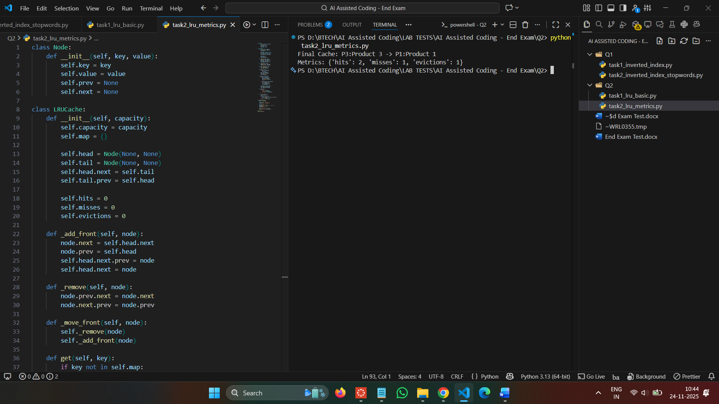

Observation:
The LRU cache ensures that the most recently accessed items stay in memory while the least recently used ones are removed.
It improves performance by reducing repeated data loading.
The cache correctly updates usage order whenever an item is accessed or inserted.
In the second task, hit, miss, and eviction metrics clearly show how efficiently the cache handles requests.
Overall, LRU helps optimize memory usage and tracks its behavior through these metrics.

